**Agile methodology is a project management and software development approach that emphasizes flexibility, collaboration, and customer-centricity."**

**Agile manifesto** describes 4 core values, as listed below.

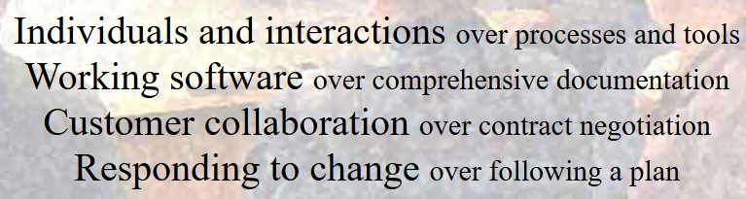

The **12 principles of agile software development** as outlined in the Agile manifesto are listed below. In other words, based on the 4 agile manifestos, these 12 principles are derived.

Agile is completely based and operates around these 4 manifestos and 12 principles.

* ***Satisfy the Customer***
* ***Welcome Changing Requirements***
* ***Deliver Working Software Frequently***
* ***Work Together***
* ***Motivated Individuals***
* ***Face-to-Face Conversations***
* ***Working Softwares***
* ***Sustainable Development***
* ***Good Design***
* ***Simplicity***
* ***Self-organizing Teams***
* ***Inspect and Adapt***

Please find below the list of **Agile framework and methodologies**. However, the most commonly used methodology is Scrum and Kanban. A few segments have started using Scrumban too to an extent. We shall look at this specifically during the session.

* ***Scrum***
* ***Kanban***
* ***Scrumban***
* ***Extreme Programming (XP)***
* ***Crystal***
* ***Feature-Driven Development (FDD)***
* ***Lean***

Please find below the **best practices of Agile**, this is more or like, listing the key pointers from **agile manifesto**and **principles**combined:

* ***Customer collaboration***
* ***Continuous Integration***
* ***Pair programming***
* ***Burndown charts***
* ***Code Review***